Parent/Carer Guide to the Parent Evening Booking Tool:

Introduction
Your school will have provided you with a Starz+ login; you will need this to access your school’s Starz+ platform to book your appointment. Please note that currently the booking tool is not assessable using the Parent App, you will need to access the platform via a web browser.

Logging on
Your school should have provided you with a web address directing you to the login page for the school’s Starz+ platform. If this is not the case, you can locate your school on:
www.ccc-computing.org.uk/find-my-school .
If you find that you have arrived at the school’s website, then look for the ‘Green’ login button at the top right-hand corner of the screen. On arriving at the login page, enter your username and password as provided by the school. Please contact the school office if the password requires a re-set. NB: You will need to keep your login details as you will be required to login each time term that the school arranges parent consultations.

Your Dashboard
The first page you arrive at will be your ‘Dashboard’, an example of which is shown below. This may/may not have all the same items displayed; this is dependent on what your school has activated for parental accounts:
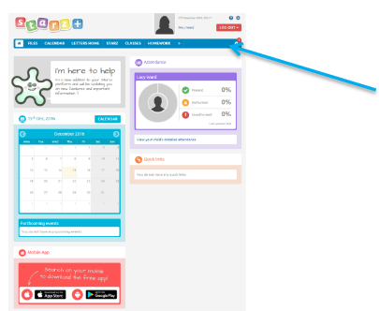
It is on the menu bar that you will locate the Parent Evening Booking Tool.
If it is not showing you may need to click the double arrows >> to access overflow items.

Click on ‘Parents Evening’, tool link.

Making a Booking
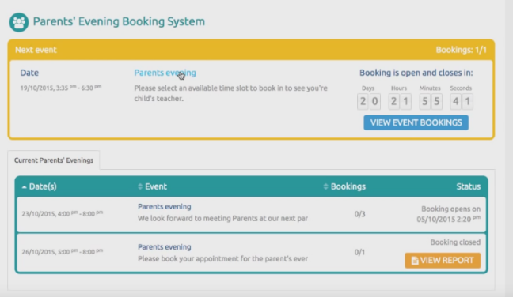
On the next screen, you should see displayed current Parent Evening sessions, together with any that are set for the future.

If more than one date is available, click onto the date which suits you best.
On the next screen, you will see your child’s name displayed. Click onto this to make your booking. You will now see displayed the options for booking. – Select the blue ‘Book/View’ button.
A small window will open to provide you with an oversight of all available slots, these are indicated in green. Any slots shown in grey depict a consultation time allocated to another parent/carer and therefore unavailable.
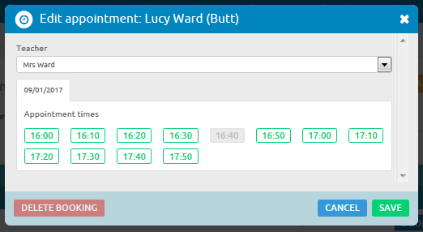
Once you have selected a time slot for yourself, it is possible to delete the booking at any time and reschedule for any other available time.
Once a consultation time has been booked it is also possible to generate and print a report using the orange ‘Generate Report’ button.

