Welcome to Sutton CofE Primary School

Getting ready to step into Reception

My name is………………………………………………

This is me

Please draw a picture of yourself or add a photo

This booklet is designed to support your child prepare for Reception and for their Reception teacher to get to know and get ready for them.

Your teachers will be Mrs Small and Mrs Pitt

When you start school you will need a school uniform.
You will also need a PE kit.
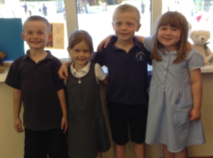

We wear jogging bottoms, a t-shirt, a jumper and trainers or plimsolls when we do Outdoor PE.
We wear a t-shirt and shorts when we do Indoor PE.
Remember to ask an adult to put your name in all your clothes, just in case you misplace them.

You will have a peg with your name on to hang your coat, book bag and PE kit up.

You should bring a water bottle to use at play times and in class. This goes in the box in the cloakroom. Remember to only put water in your bottle.
If you have a packed lunch then your lunch box goes in the large box in the cloak room.

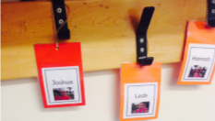
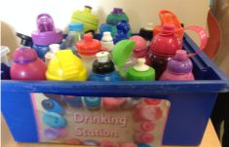

We eat lunch in the big hall. There are lots of adults around to help you if you need it.
You can choose to have a school hot dinner or a packed lunch.
Remember no nuts or fizzy drinks are allowed. Sandwiches, fruit and yoghurts are good choices.
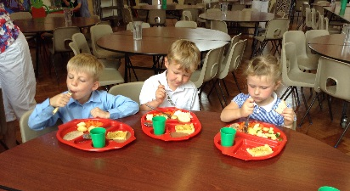

If you need the toilet, just ask an adult. The blue and yellow toilets are for the boys. The red and yellow toilets are for the girls.

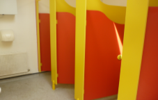
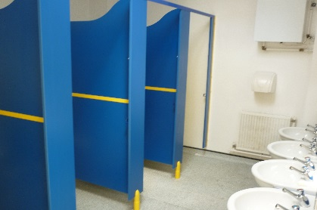

We’d like to know a bit more about you.

Can you tell us about your family?

What do you like doing?

Is there anything you might need help with when you start school?

Is there anything you are worried about or would like to know more about before you start your new class?

Before you start school in September don’t forget to make your ‘This is me box’
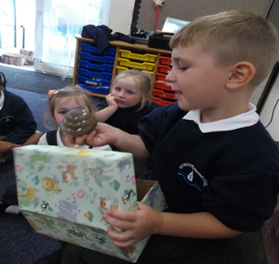

Could you also send in a drawing and a photo of yourself before the week beginning 13thJuly

This booklet will be included in your pack that will be sent to you and we will look at it with you on either your home visit or when you start school.

We can’t wait to see you at the start of term.
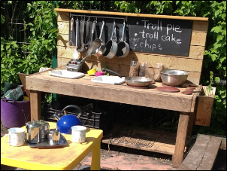
Don’t forget to look at Dojo for story times before the end of term.

