Continuing My Learning Journey at Sutton CofE Primary School

Getting ready to step into Year One

My name is……………………………………………………………….

This is me

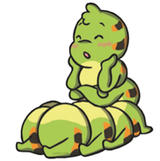

Please draw a picture of yourself or add a photo
This booklet is designed to support your child prepare for year one and for their year one teacher to get to know and get ready for them.

Please read and enjoy this story together

It was springtime in the garden. Cody the Caterpillar hatched from her egg and crawled onto a big green leaf.
She smiled happily. “I love being a caterpillar!” she said and began to eat her tasty leaf.
Just then, a ladybird flew on over.
“You’re very lucky!” said the ladybird. “When you become a butterfly, you will have wings, like me!”
“Flying looks very tiring,” said Cody. “I wish I could stay as a
caterpillar forever!”

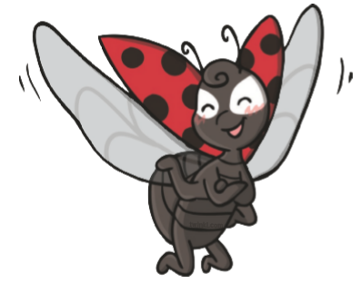
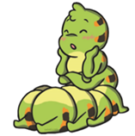

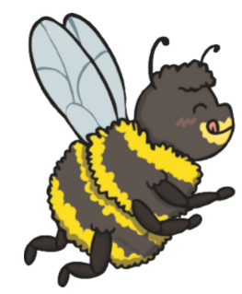
The next day, a bee buzzed on over.
“You’re very lucky!” said the bee. “When you become a butterfly, you will sip nectar like me!”
“I don’t think I will like nectar,” said Cody. “I wish I could stay as a caterpillar forever!”

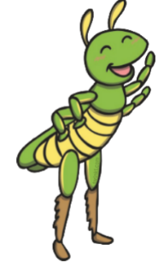
A few days later, a grasshopper jumped on over. “You’re very lucky!” said the grasshopper. “When you become a butterfly, you will have six legs, like me!”
“But I like having sixteen legs,” said Cody.
“I wish I could stay as a caterpillar forever!

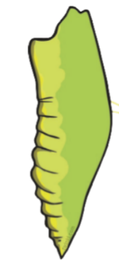
The next day, Cody was full. She thought about everything her friends had told her and decided to be brave. She changed herself into a chrysalis and stayed like that for many days, until she was finally ready to leave her chrysalis…... …………….and become a butterfly!
That evening, she came across a caterpillar eating a tasty green leaf. The caterpillar smiled but didn’t look sure.
“I wish I could stay as a caterpillar forever!” he said.
“Don’t worry,” said Cody. “I loved being a caterpillar too, but trust me, being a butterfly is great!”
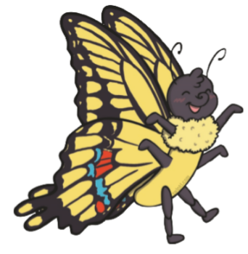

Please tell your new class teacher about yourself.
What do you like doing?

Who are your friends?

What are you good at?

What are you looking forward to in year one?

Is there anything you are worried about or would like to know more about before you start your new class?

You may have a new classroom next year
You may have a new class teacher
You will have some new children in your class
but please remember you are amazing and like the Cautious Caterpillar you are ready for the next step of your journey.

You are ready for Year One
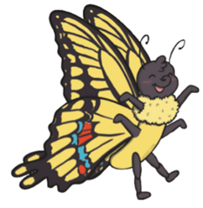
It will be such fun

