Transitioning to Year 5/6

Name ____________

Year ___________

New Class ___________

Welcome to Year 5/6! We know that you are probably a little more nervous than usual about starting your new class in September. We would like you to fill in this booklet so your new teacher can get to know you. We will also try and answer any of the questions or worries you have. The teachers will also fill in a booklet so you can get to know them.
All about me!
Please could you draw a picture or stick a photo of you here:
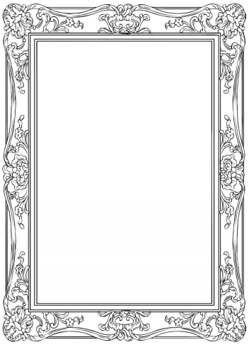
You can write, draw pictures or both in the boxes below.
Things I enjoy doing in my free time:

Subjects I enjoy doing at school:

Friends I am looking forward to seeing when I get back to school:

Things I am looking forward to doing when we get back to school:

Questions I would like to ask my new teacher. These can be about them or about school.

Signs I might be worried and how people can help me if I am worrying.

